Introduction:
This document was created to assist with the update of ESXi 7.0U3l build 21424296 from 7.0U3d build 19482537 in DCR plant.
Procedure:
Access the Lifecycle Manager plug-in via the vSphere Client, by browsing to Menu > Lifecycle Manager
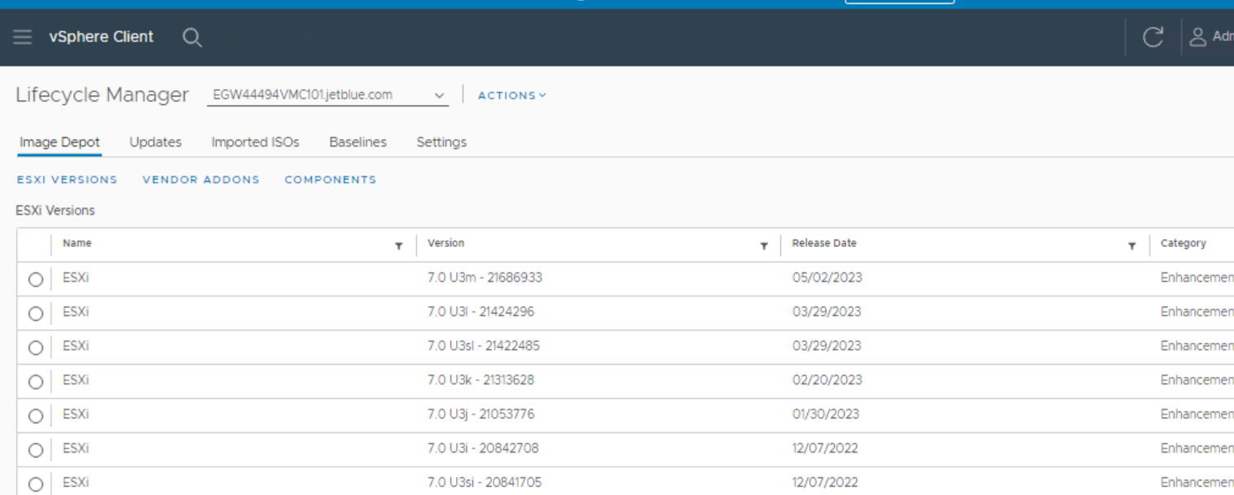

- Select a vCenter server from the dropdown menu and click the Import ISOs\update tab
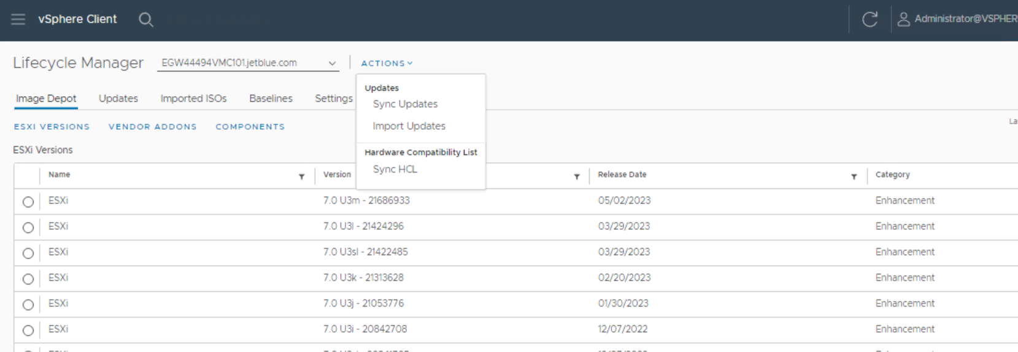

- Click on IMPORT ISO and select the iso image from the local drive. (Initially we need to import ESXi 7.U3i Dell customized ISO)
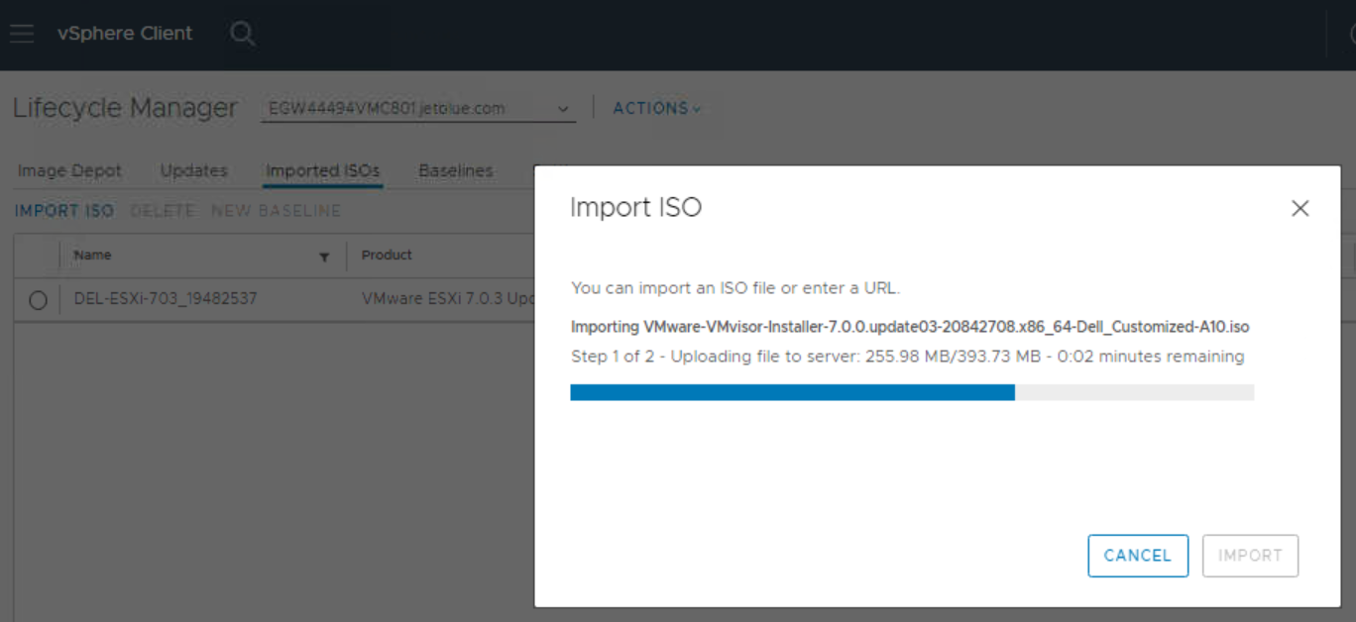
- Click on IMPORT update and select the downloaded zip image from the local drive. (once Dell image uploaded we need to import ESXi 7.U3l zip file)

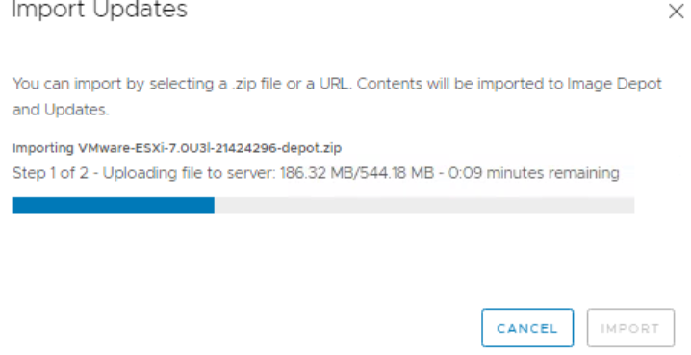

- Select New > Baseline in the Baselines tab of the Lifecycle Manager plug-in. This will launch the Create Baseline dialog

- In the Create Baseline dialog, enter a Name for the baseline, select the Upgrade radio button, and click Next
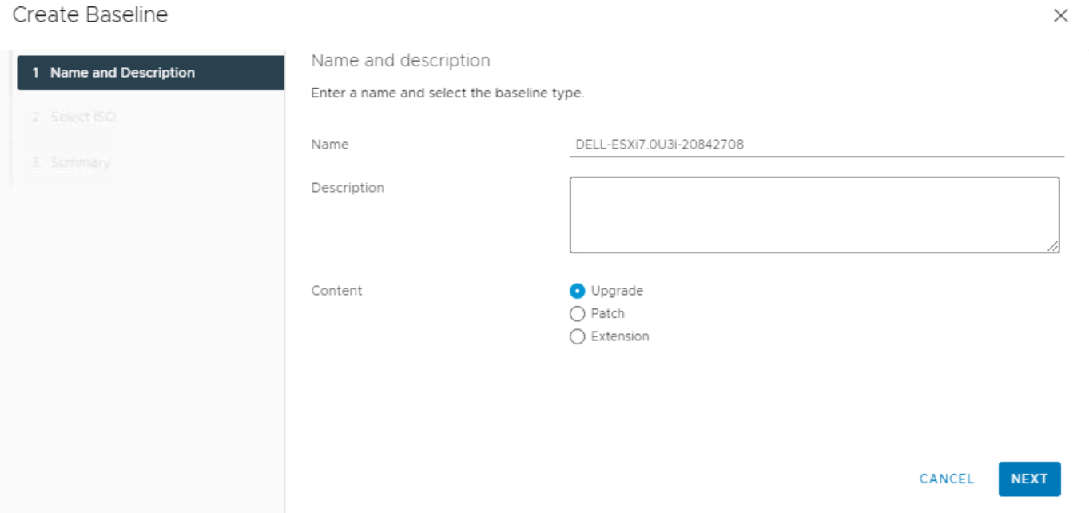

- Select the DEL-ESXi-703_20842708-A10 image and click Next. 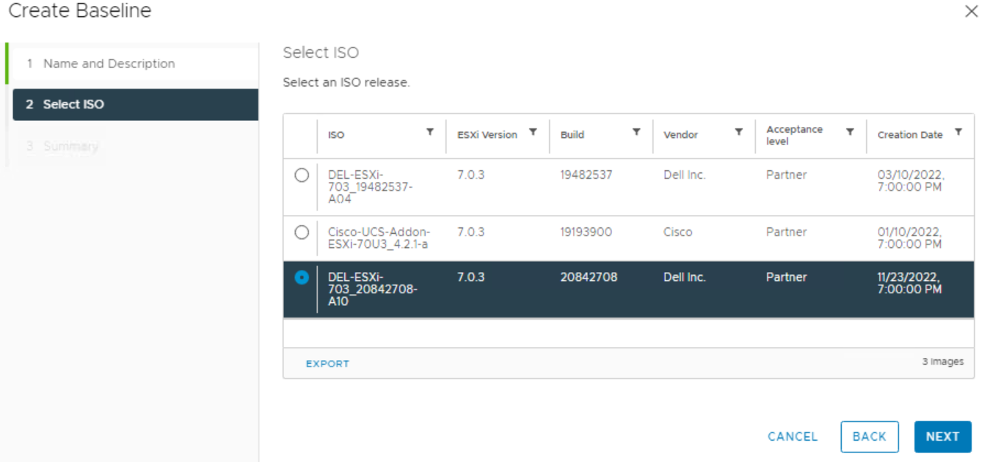
- Finally, review the Summary tab information and click Finish to create your custom baseline.

- Attach the DEL-ESXi-703_20842708-A10 baseline to a vSphere cluster and check compliance.

- Put the host in maintenance. If host in vSAN cluster, Select the Ensure accessibility

- Log in to vSphere Web Client and click on the Host > Updates

- Select the ESXi7.0U3i-20842708 baseline and Click Remediate
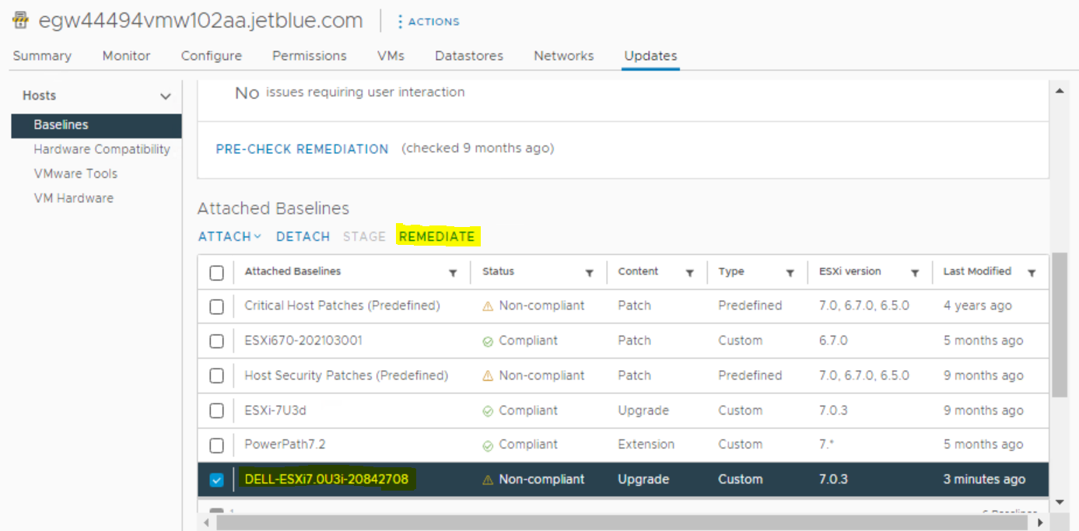

- Click on Remediate button below
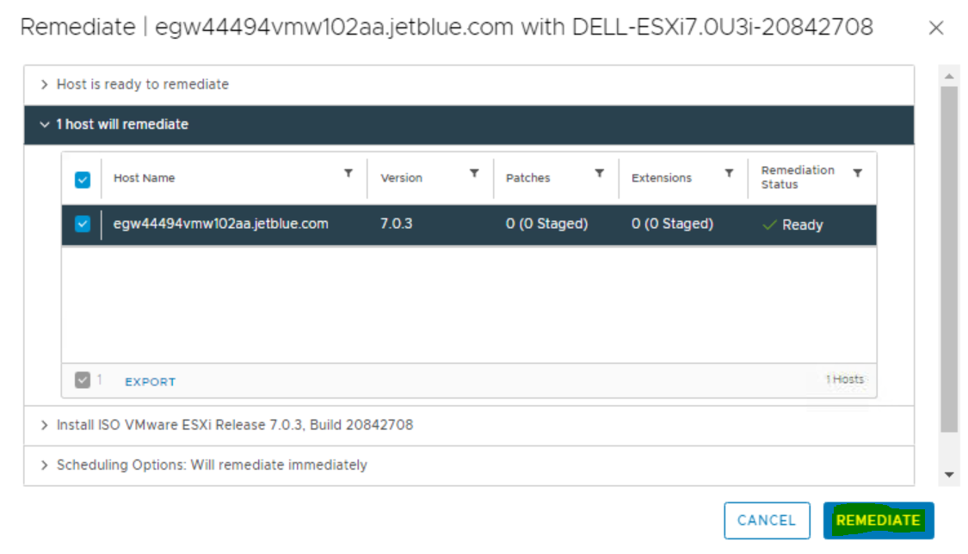

- Go to Monitor menu and select the Tasks to know the status of progress.
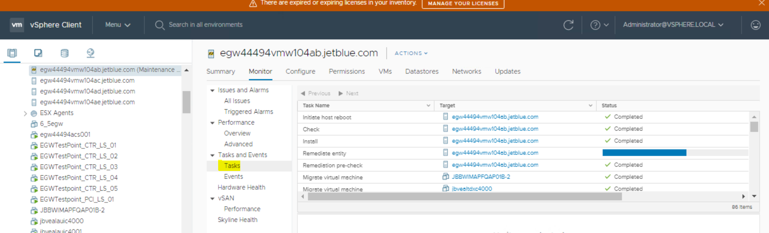

- Once the update has completed and back to connected status, do the basic health check.
- Once the host gets upgraded to ESXi 7.0 U3 i then we need to apply the ESXi 7.0 U3L patch, hence follow similar steps. Below screenshots are for illustrations.
Create a Baseline and patch with ESXi U3 L updates.
- 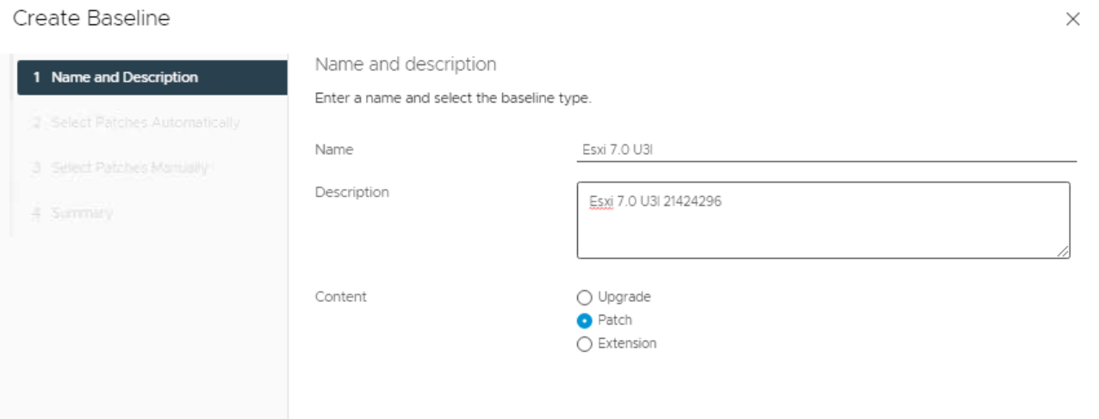
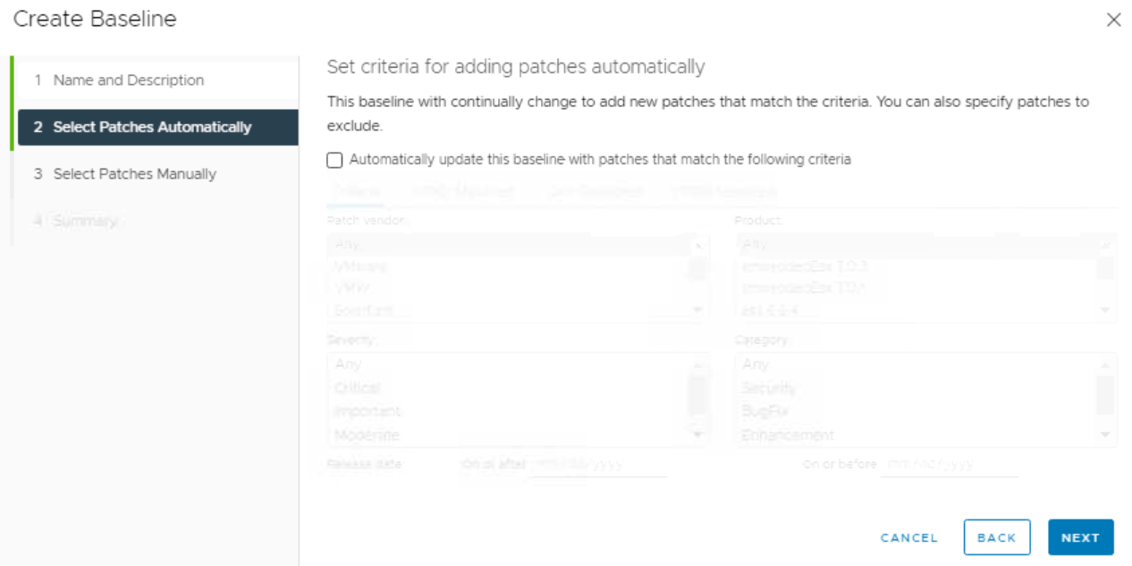

- 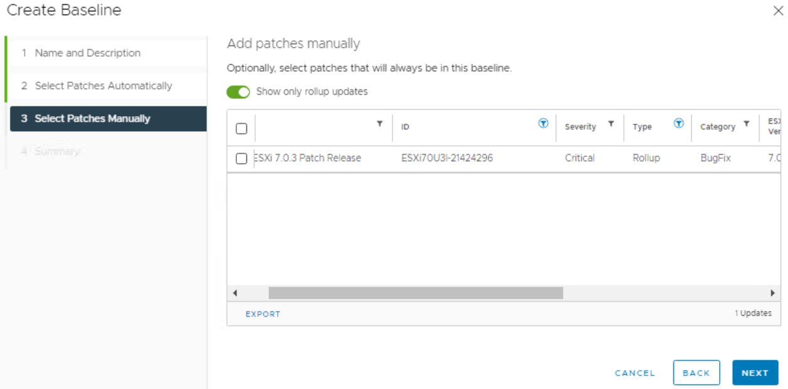
- 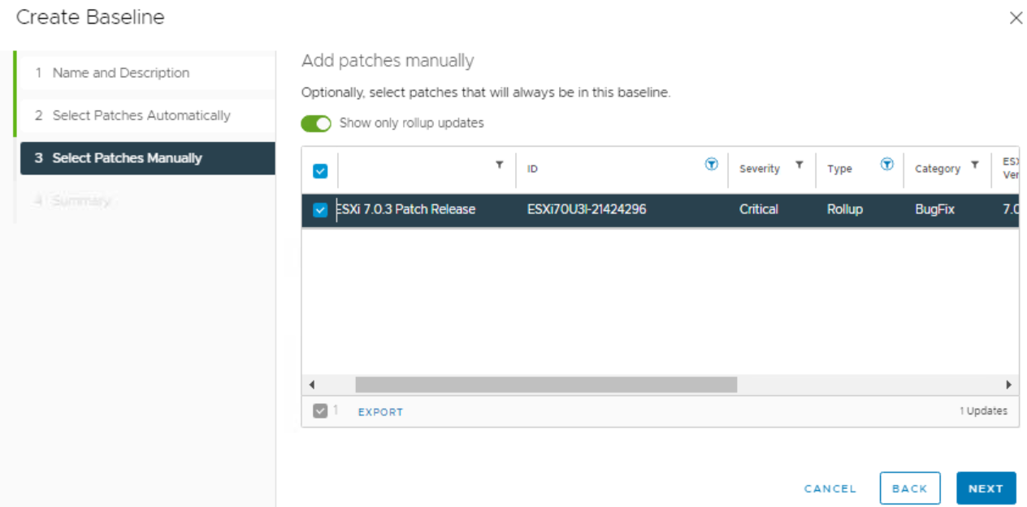
- 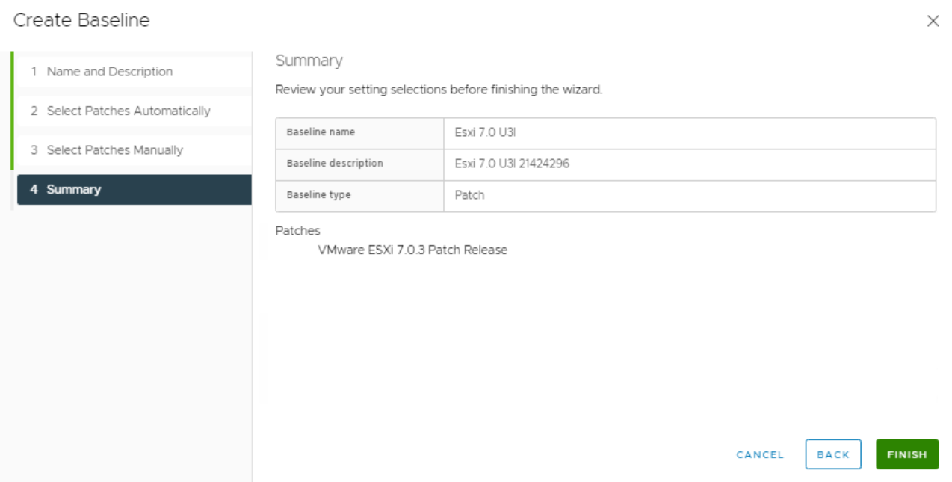
- 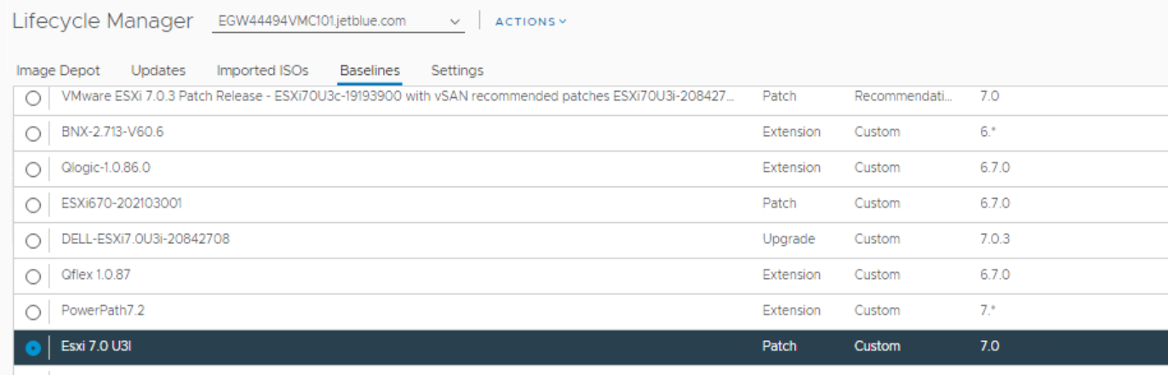
- 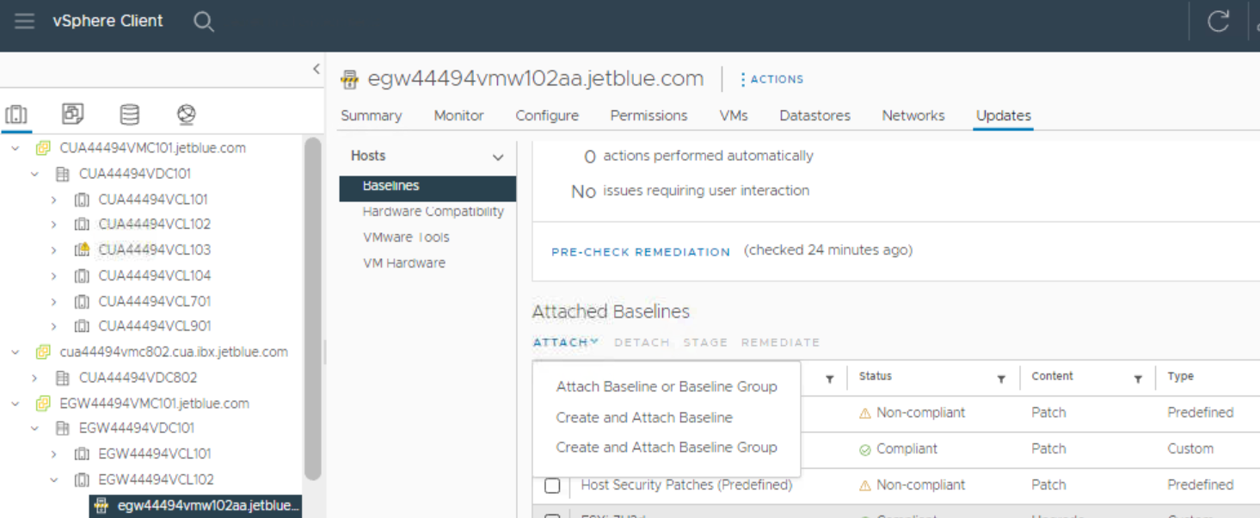
- 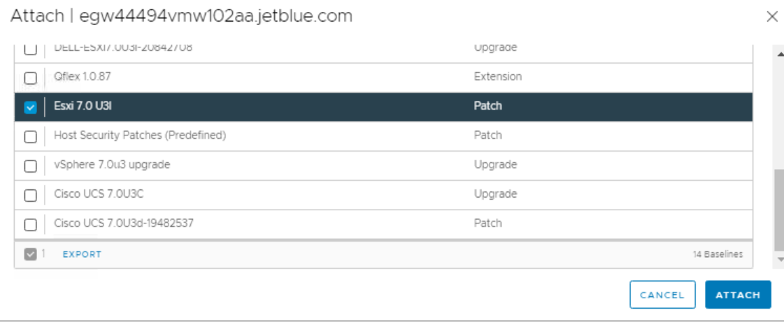
- 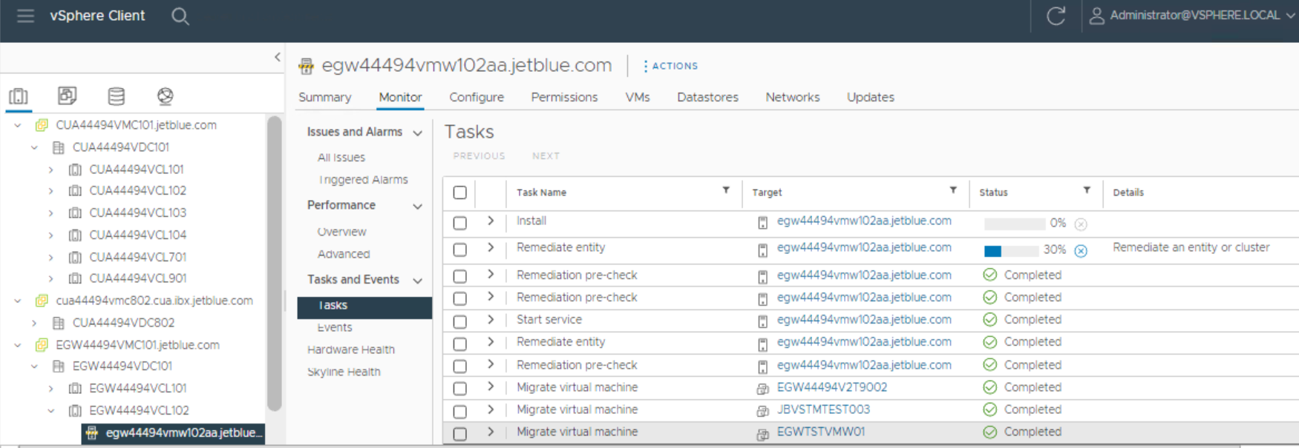
- 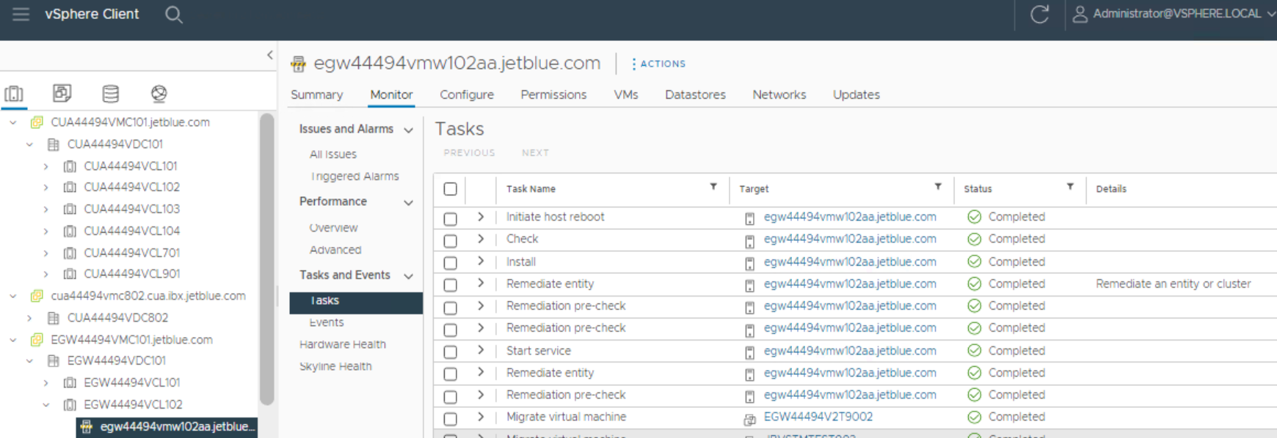

- 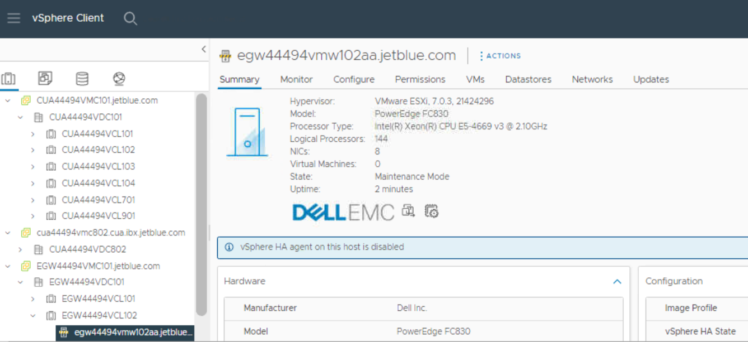

- Exit the host from the maintenance.

